

TRAINING REPORT

**OF**

**SIX MONTHS INDUSTRIAL TRAINING, UNDERTAKEN**

**AT**

**“CS Soft Solutions”**

**IN DEPARTMENT ON**

**IMDb Clone**

**SUBMITTED IN PARTIAL FULFILLMENT OF THE DEGREE**

**OF INTEGRATED BCA-MCA/BCA**

**Under the Guidance of: Submitted By:**

**Name:** Mr. Arun Sharma **Name:** Rohan Mondal **Designation:** React Native Developer **University ID No:** 1813987016 **Department:** Mobile

# DECLARATION

I hereby declare that the dissertation entitled Training Report submitted for the Integrated MCA Degree is my original work and the dissertation has not formed the basis for the award of any degree, associateship, fellowship or any other similar titles.

Name: Rohan Mondal

Roll No: 1813987016

# ACKNOWLEDGEMENT

I would like to express my sincere gratitude to all those who provided me the possibility to complete this report. I would like to give a special thanks to our project manager, whose contribution in stimulating suggestions and encouragement, helped me to coordinate my project especially in writing this report.

I am thankful to all the teaching staff and placement cell of Chitkara University for providing this wonderful opportunity to undertake this internship and for providing their valuable inputs and support whenever I faced any issue.

I am very grateful to all the members of CS Soft Solutions Team, with whom I have worked, for constantly supporting and training me.

I would also like to express my gratitude towards all the Team Members of the Portals Team for helping me out constantly. Finally, special thanks to my family, who supported me throughout the internship.

Thank You

**PREFACE**

This report has been prepared as part of my Six Months Industrial Training, as a part of Integrated M.C.A. The report consists of all the activities, tasks and project I was assigned during the Industrial training of six months.

This consists the overview as well as the explanation of all the modules under the project assigned to me.

It consists of multiple sections such as Feasibility study, Requirement analysis, modular description of the job, data flow diagrams, flowcharts, testing details, conclusion, references etc.

The report will give an overview of the things I have learned at the workspace. The report further will continue by giving an overview about the project I have worked on.

# TABLE OF CONTENS

DECLARATION 2

ACKNOWLEDGEMENT 3

CERTIFICATE 4

PREFACE…………………………………………,,,,,, 5

PROJECT UNDERTAKEN 8

INTRODUCTION TO ASSIGNED JOB 10

KEY RESPONSIBILITIES 12

FEASIBILITY STUDY 13

INTRODUCTION TO IMDb 16

REQUIREMENT ANALYSIS 17

ANALYSIS OF INDIVIDUAL MODULE 20

* SIGN IN PAGE MODULE 20
* SIGN UP PAGE MODULE 21
* HOME PAGE MODULE 22
* SCEARCH SCREEN PAGE MODULE 23
* VIDEOS SCREEN PAGE MODULE 24
* PROFILE PAGE MODULE 25
* MOVIE READER MODULE 26
* STATIC DATA ARRAY 27

FLOW CHART 31

TESTING 32

CODING 34

FUTURE SCOPE 40

CONCLUSION 41

REFERENCES 42

# PROJECT UNDERTAKEN

## Background

The largest industries in the world that is catering to billions of jobs in the world. There are different movie industries that have flourished around the world depending on the countries, languages, and province. As time goes on, these industries have evolved. More technology has been added in these industries like cameras, editing, special effects, graphics, distribution, and more. Each industry is thinking about the best performance for what they want to remove the hurdle and want to propel their business. In the movie industry, the biggest issue is a lack of trust in upcoming movies. The industry's promotion and marketing teams have addressed this issue by launching trailer, teaser, posting advertisements on television, magazines and social media platforms, hosting a social event like a fundraiser or a donation for a cause.

Despite of various campaigns by the marketing and publicity teams, good movies do not perform well as they deserve. My project aims to strengthen the trust in viewers by giving prediction whether a movie is a hit or a flop so a person can decide to watch the movie or not. This application currently works on the Indian Bollywood and Hollywood industry due to small data size and quality of data.

## Purpose

The purpose of this application is to provide the prediction of performance for an upcoming movie in theatres by calculating the previous movie performances of the star cast, director, producer, and music director from historical datasets using a simple arithmetic equation. This application takes account of a member from lead star cast to the music director. A movie will perform well when every member of the

team works in cohesion. This application has a 95% accuracy for a prediction from the available small dataset. Based on the predictions people can decide to watch the movie or not and can save money. If a person could decide by their own self then the marketing and publicity teams could be less stressed about PR management, marketing, and all activities for reaching out to audiences.

## Existing System

In the current world, there is no such application exist which can predict a movie’s performance. Yes, there are many critics who give their reviews, and platforms where a person can go and submit their personal feelings. These all are made possible after the movie is released. The people who want to watch the movie remain perplexed by reading reviews published on various platforms. Right now, the focus is on the lead actor and actress, marketing activities like selling merchandise, print media management, promotional activities and many more. Due to all these promotional activities a hype is created for the movie, people fall in trap of these promotions and join the hype.

**INTRODUCTION TO ASSIGNED JOB**

React Native is a free and open-source mobile software program that can be used to build content on a range of platforms. They work with graphic

designers and the product team. The candidate is required to create a

flexible and well-structured front-end architecture along with APIs to support

it. The React Native developers will make visualizations that can render huge

quantities of data.

React Native is great for mobile apps. It provides a slick, smooth and responsive user interface, while significantly reducing load time. It's also much faster and cheaper to build apps in React Native as opposed to building native ones, without the need to compromise on quality and functionality. It functions in the same way as React does. This one, nevertheless, does not use the DOM. Serialization, asynchronous, and batched bridge are used to engage directly with context systems in this one.

Using the features of a Native Platform, coordination takes place between the interface and the end-device.

It is a wonderful architecture for programming for various platforms with a single code base. It is a fantastic architecture that allows you to code for different platforms with a single script, allowing you to make hybrid apps. This quickens the speed of the job while still lowering the costs. The architecture is entirely Javascript-based and does not use HTML.

React Native Developers have been in high demand for a number of years. The explanation for this is straightforward: the architecture allows developers to use the same code across different platforms. This not only reduces the time it takes to deliver an app but also reduces the expense of producing one. However, this is not the only explanation for its widespread use. The applications created with the platform are nearly similar to native apps, and they can be designed in any way.

# KEY RESPONSIBILITIES

* Design and implement user interface components for JavaScript-based web and mobile applications using React ecosystem
* Work as a part of a small team that includes other react native developers, designers, QA experts, and managers
* Build app and UI components from prototypes and wireframes
* Work with native modules as and when required
* Use Native APIs for tight integrations with both platforms – Android and iOS
* Write automated tests to ensure error-free code and performance
* Improve front-end performance by eliminating performance bottlenecks
* Create front-end modules with maximum code reusability and efficiency
* Implement clean, smooth animations to provide an excellent user interface

# FEASIBILITY STUDY

Feasibility Study is the most important part for the development. It studies aspects of the present, experience and future and tries to answers that would arise in any project manager’s mind.

The feasibility study is conducted when the problem is answered and understood. The feasibility study will determine if a proposed system deserves an investment of time and money.

Through the feasibility study, the management can visualize the proposed system. The most popular decision-making feasibility studies are Technical, economical and operational. The feasibility study considers product idea, on ground demand, technical feasibility and many more. when report is generated all the future problem will be address and eliminated them before they arise.

Here, we are going to study three different feasibility aspects for the proposed- system which are technical aspects, economical aspect, and operational aspect. These aspects also addresses the new proposed system.

Technical Aspect:- Technical feasibility is providing the estimation for a minimum amount of technical skills required. Upon the estimation, a developer can predict whether they must gain knowledge or not. In this estimation following are the requirements.

* This system is maintainable for new updates or release
* This system should be secure, scalable and optimum.
* This system is responsive. When all the requirements are met the system is said to be technically feasible

Operating System : 11(ultimate & enterprise) Languages : React Native

Software : Android studio

Economic Feasibility:- Economic feasibility is one of the major factors. In this project one say that this project is financially feasible because it requires no extra financial investment, this project can be completed in six months. In economic feasibility, existing projects are compared based on future financial benefits of the proposed system with the equity, return on investment is 8 calculated. Profits are expected on the investments. If a system gives more returns compared to investments then the system is financially feasible. Economic Feasibility will conclude whether

* The cost during the development includes tools.

The returns of this project comparing to the investments is very good. So this project is economically feasible because it is giving more returns compare to investments.

Operational Feasibility In this step, all different operational factors are determined of the proposed systems like work force, time, etc. to design, develop and maintain this system. whichever solution uses least amount of effort, is the best operationally feasible solution.

Operational Feasibility :- It determines whether the proposed system satisfies all clients' demands and functionalities.

* Work culture, style of executions, planning and the design of the product should

be accepted by all the members. The proposed system will not cause any problem under any circumstances to the end-user and works properly.

In this feasibility study the time and personal requirements are satisfied. so this solution is operationally feasible.

the project can be done from available resource or not. Financial benefits should be greater then investment. In this feasibility following are checked:

* Cost price for full system investigation.
* The installation and operational cost for the system.

## INTRODUCTION OF IMDb

The Internet Movie Database (IMDb) is an online database containing information and statistics about movies, TV shows and video games as well as actors, directors and other film industry professionals. This information can include lists of cast and crew members, movie release dates and box office information, plot summaries, trailers, actor and director biographies and other trivia.

Information on IMDb comes from a variety of sources, such as filmmakers, film studios, on-screen credits and other official sources. However, much of the information comes from IMDb users themselves, who can submit facts in a [wiki](https://www.techtarget.com/whatis/definition/wiki)- style format. Unlike traditional wiki sites, IMDb always authenticates information before it appears online -- although errors do show up, and the website allows users to report possible mistakes so they can be fixed.

Users can also submit reviews of movies and TV shows on a one to ten scale, which are then used to create a weighted mean of all user reviews to be displayed on the movie or TV show's page. Also, these ratings are used to compile IMDb's Top Rated and Lowest Rated lists of movies and TV shows.

IMDb was first published in 1990 by Col Needham, a computer programmer, as a group of scripts which allowed users to search a list of film credits that were compiled with the help of a USENET group. The database was incorporated in 1996. In 1998, Internet Movie Database Ltd. became a subsidiary of [Amazon](https://www.techtarget.com/whatis/definition/Amazon), which uses it as a way to advertise movies and DVDs which it sells on its main website.

In 2002, IMDb launched its paid subscription service for film industry professionals, IMDbPro. IMDbPro allows actors, directors and other professionals to manage their IMDb page, upload their résumé and access more extensive information not available on the free version of the website.

In addition to the IMDb website, the company offers a mobile app which is available [Android](https://www.techtarget.com/searchmobilecomputing/definition/Android-OS) devices.

# REQUIREMENT ANALYSIS

**Visual Studio Code:** Visual Studio Code is a streamlined code editor with support for development operations like debugging, task running, and version control. It aims to provide just the tools a developer needs for a quick code-build-debug cycle and leaves more complex workflows to fuller featured IDEs, such as Visual Studio IDE.

**Android Studio: Android Studio** is the official Integrated Development Environment (IDE) for android application development. Android Studio provides more features that enhance our productivity while building Android apps. Android Studio was announced on 16th May 2013 at the Google I/O conference as an official IDE for Android app development. It started its early access preview from version 0.1 in May 2013. The first stable built version was released in December 2014, starts from version 1.0. It has a flexible Gradle-based build system. It has a fast and feature-rich emulator for app testing. Android Studio has a consolidated environment where we can develop for all Android devices. Apply changes to the resource code of our running app without restarting the app. Android Studio provides extensive testing tools and frameworks. It supports C++ and NDK. It provides build-in supports for Google Cloud Platform. It provides a unified environment where you can build apps for Android phones, tablets, Android Wear, Android TV, and Android Auto. Structured code modules allow you to divide your project into units of functionality that you can independently build, test, and debug.

## Versions of Android:

* + Android 1.0 G1 (2008)
  + Android 1.5 Cupcake (2009)
  + Android 1.6 Donut (2009)
  + Android 2.0 Eclair (2009)
  + Android 2.2 Froyo (2010)
  + Android 2.3 Gingerbread (2011)
  + Android 3.0 Honeycomb (2011)
  + Android 4.0 Ice Cream Sandwich (2011)
  + Android 4.1 Jelly Bean (2012)
  + Android 4.4 KitKat (2013)
  + Android 5.0 Lollipop (2014)
  + Android 6.0 Marshmallow (2015)
  + Android 7.0 Nougat (2016)
  + Android 8.0 Oreo (2017)
  + Android 9.0 Pie (2018)
  + Android 10.0 Q / Quince Tart (2019)
  + Android 11 Red Velvet Cake
  + Android 12 Snow Cone
  + Android 13
  + Android 14

**React Native :** React Native (also known as RN) is a popular JavaScript-based mobile app framework that allows you to build natively-rendered [mobile apps for](https://www.netguru.com/services/react-native) [iOS and Android](https://www.netguru.com/services/react-native). The framework lets you create an application for various platforms by using [the same codebase](https://www.netguru.com/blog/react-native-faq).

React Native was first released by Facebook as an open-source project in 2015. In just a couple of years, it became one of the top solutions used for mobile development. React Native development is used to power some of the world’s leading mobile apps, including Instagram, Facebook, and Skype. We discuss these and other examples of React Native-powered apps further in this post.There are several reasons behind React Native’s global success.

Firstly, by using React Native, companies can create code just once and use it to power both their iOS and Android apps. This translates to huge time and resource savings.

Secondly, React Native was built based on [React – a JavaScript library](https://www.netguru.com/blog/what-is-react-js)**,** which was already hugely popular when the mobile framework was released. We discuss the differences between React and React Native in detail further in this section.

Thirdly, the framework empowered frontend developers, who could previously only work with web-based technologies, to create robust, production-ready apps for mobile platforms.

Interestingly, as with many revolutionary inventions, React Native was developed as a response to...a big technological mistake.

# ANALYSIS OF INDIVIDUAL MODULE

## SIGN IN PAGE MODULE:

The user can sign in through the panel to follow the journey to check the ratings and further specifications.

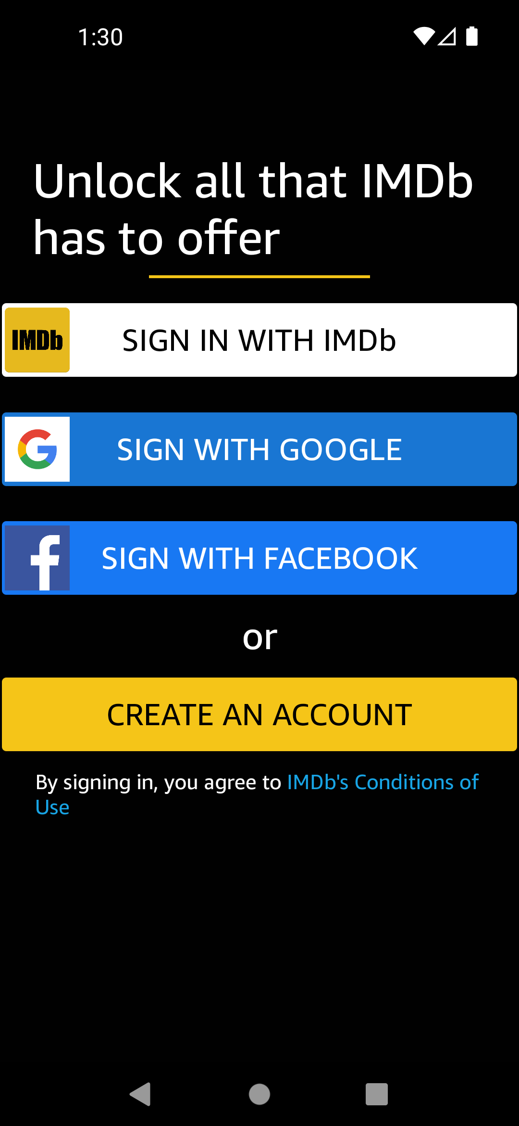

## SIGN UP PAGE MODULE:

If the user doesn’t have an account, they can create an account and sign in through the panel to follow the journey to check the ratings and further specifications.

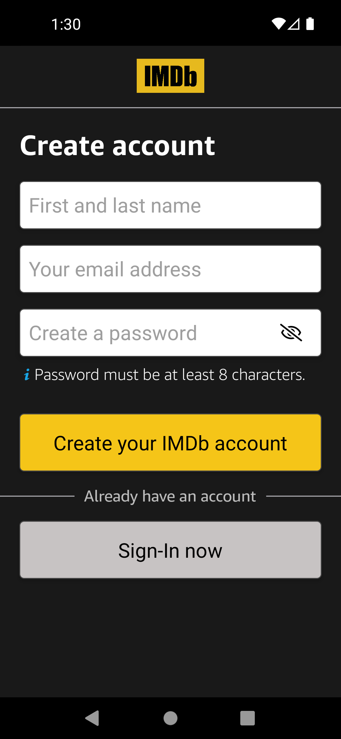

## HOME PAGE MODULE:

The user can see which movie is on the hit list and the user can check the ratings of the movie.

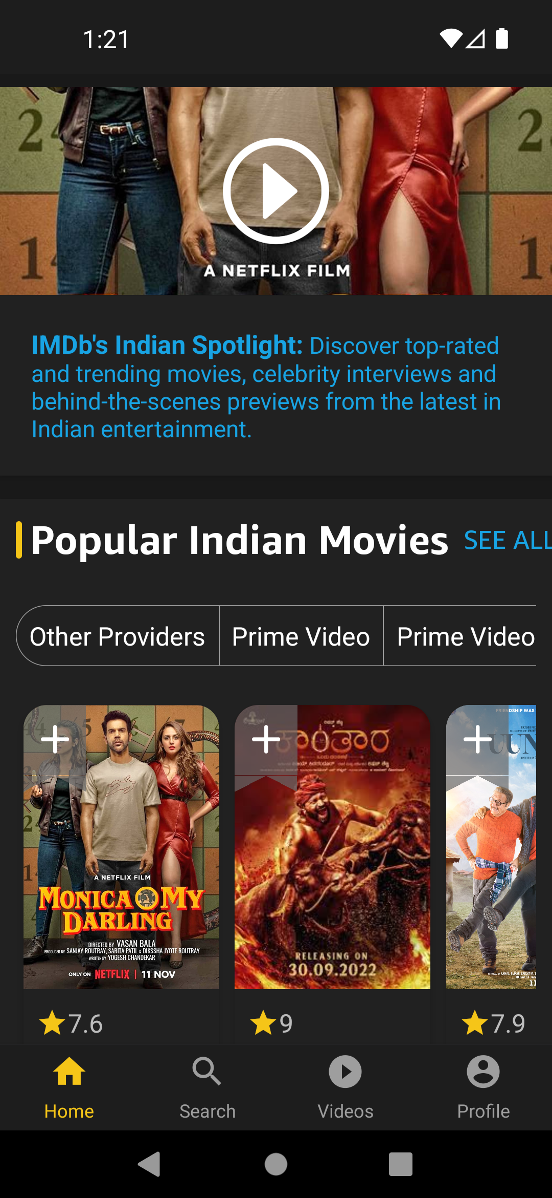

## SEARCH PAGE MODULE:

The user can search for the particular to check the ratings of the particular movie.

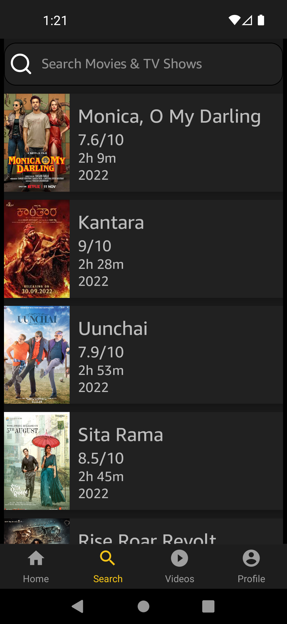

## VIDEOS SCREEN PAGE MODULE:

The user can see the latest movies and check the ratings of the movies.

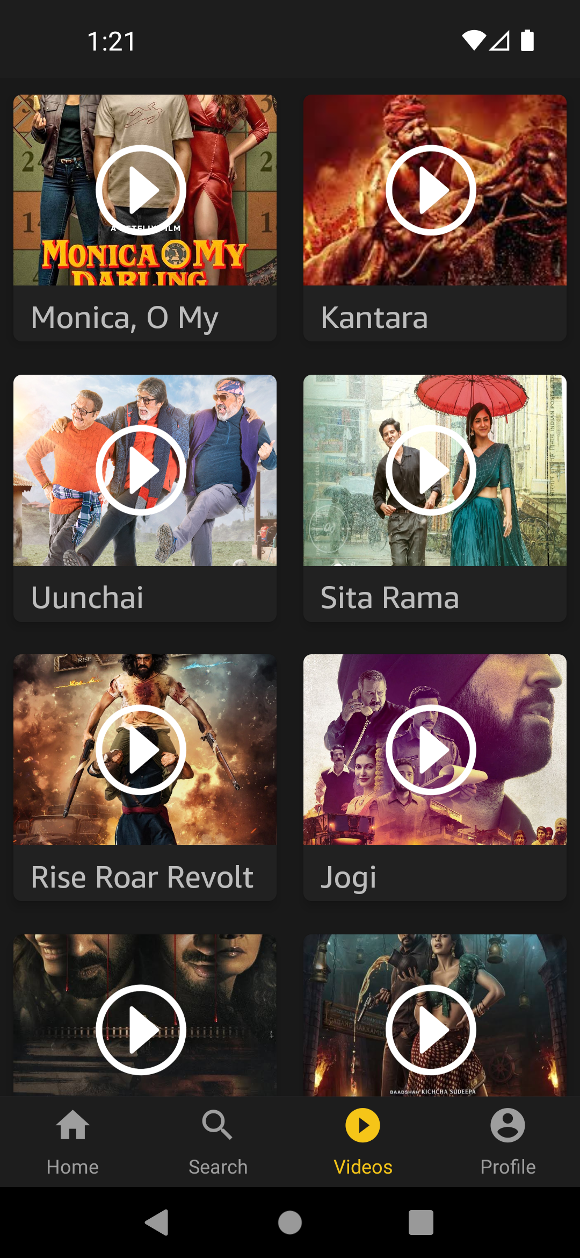

## PROFILE PAGE MODULE:

The user can check and update their profile.

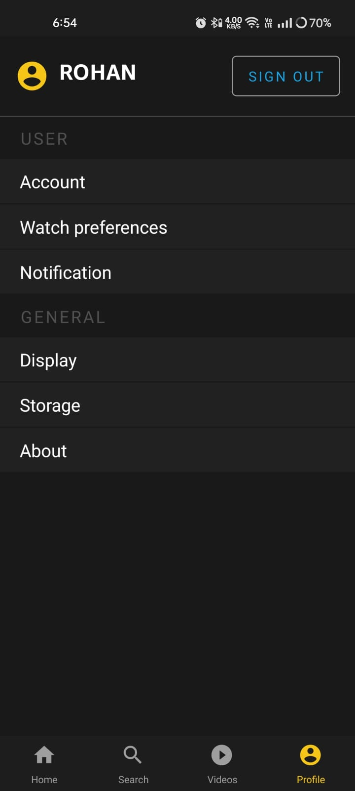

## Account Info (User Id):

The user can check their User Id.

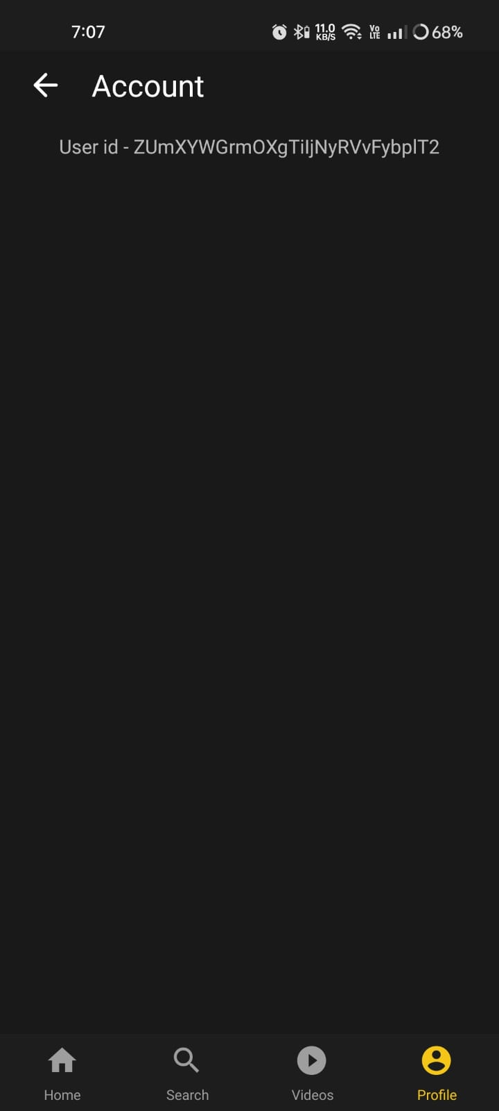

## Storage:

The user can clean App data using ‘Clear App Data’ Button.

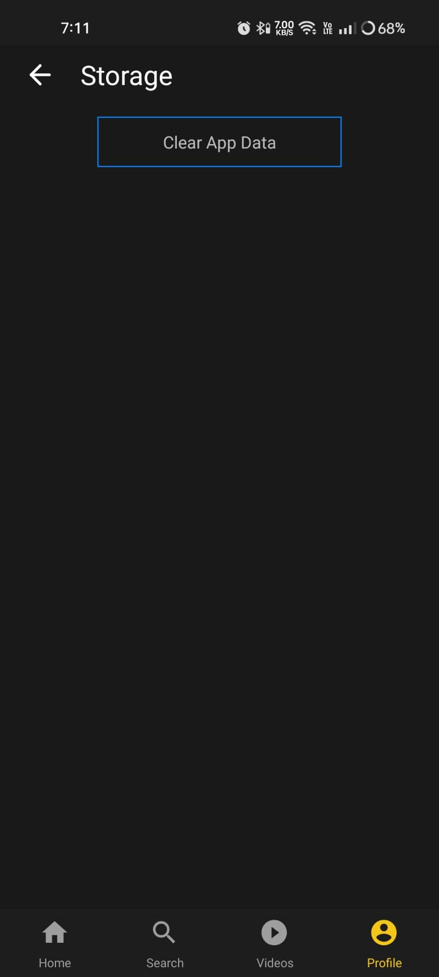

## Notification:

The user can check All the Notification.

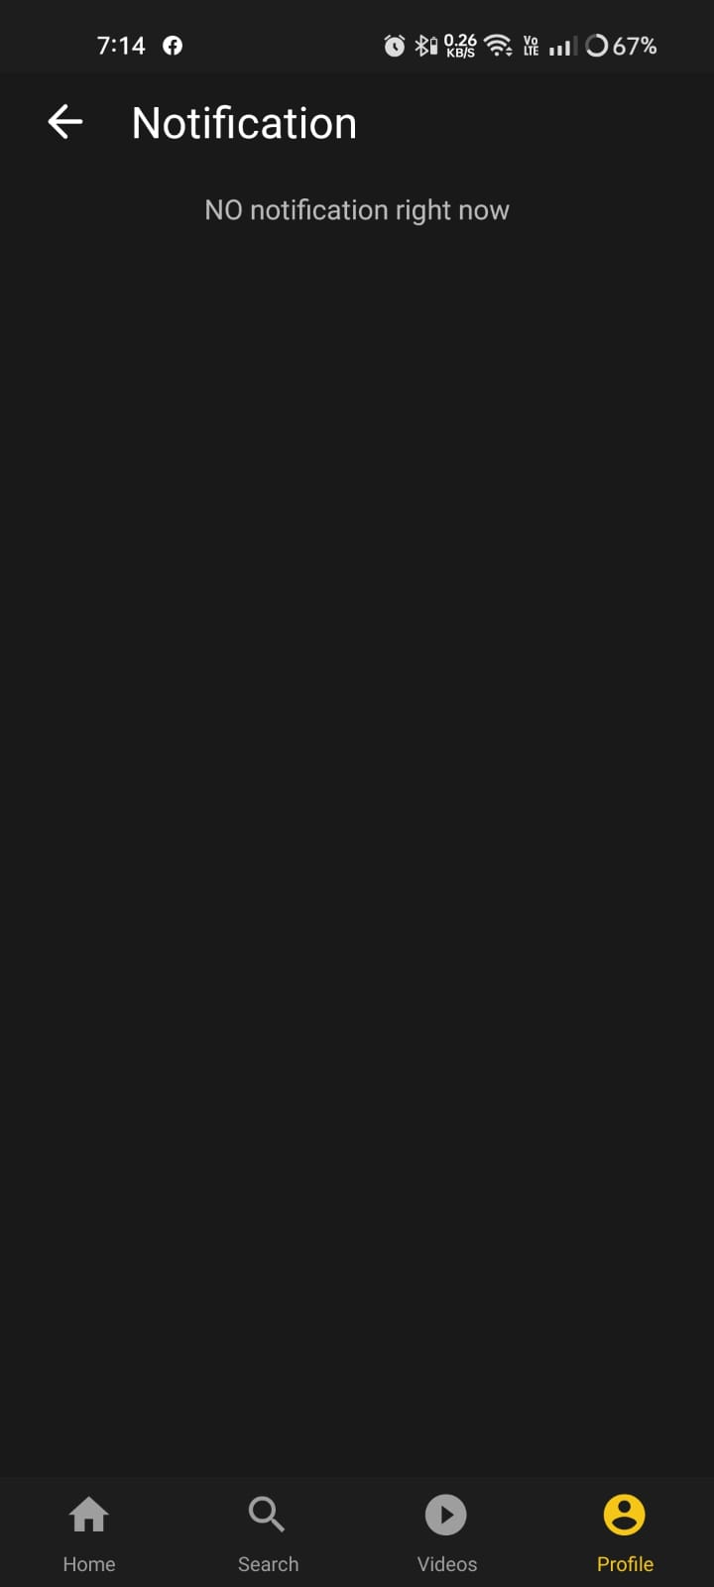

## Video 2nd Screen:

The user can watch videos.

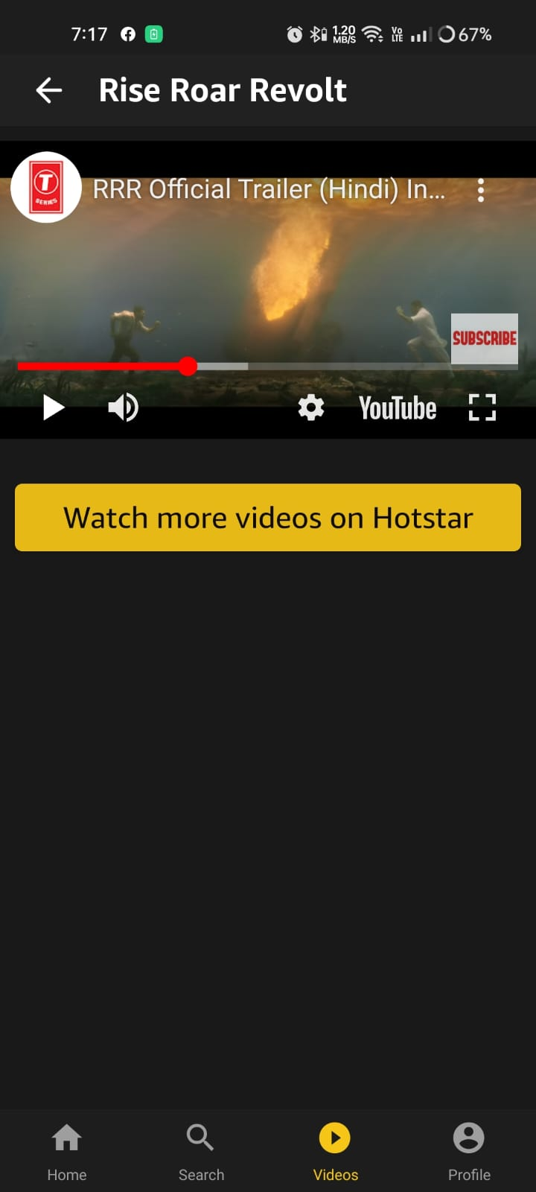

## Movie or TV Shows Detail Screen:

The user can watch movie or tv shows details.

## Watch Preference:

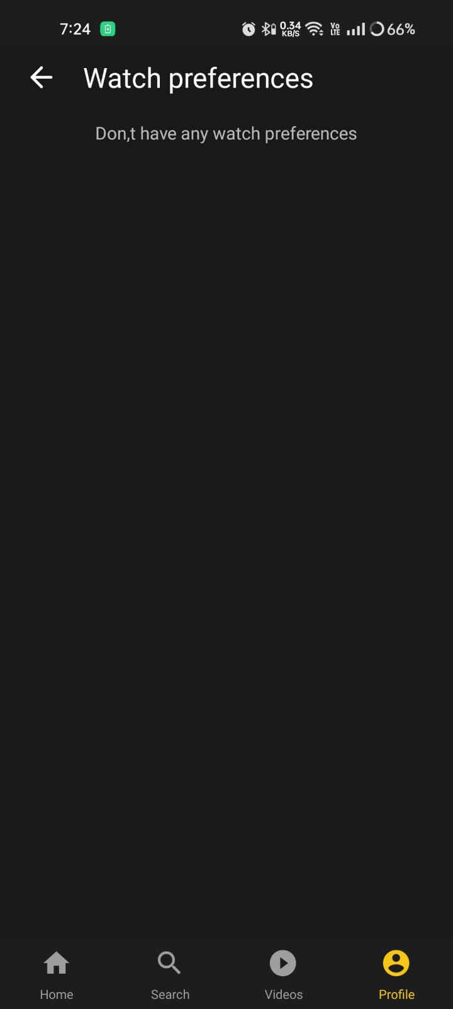

## MOVIE READER PAGE MODULE:

The user can read the details of the particular movie by clicking on the movie.

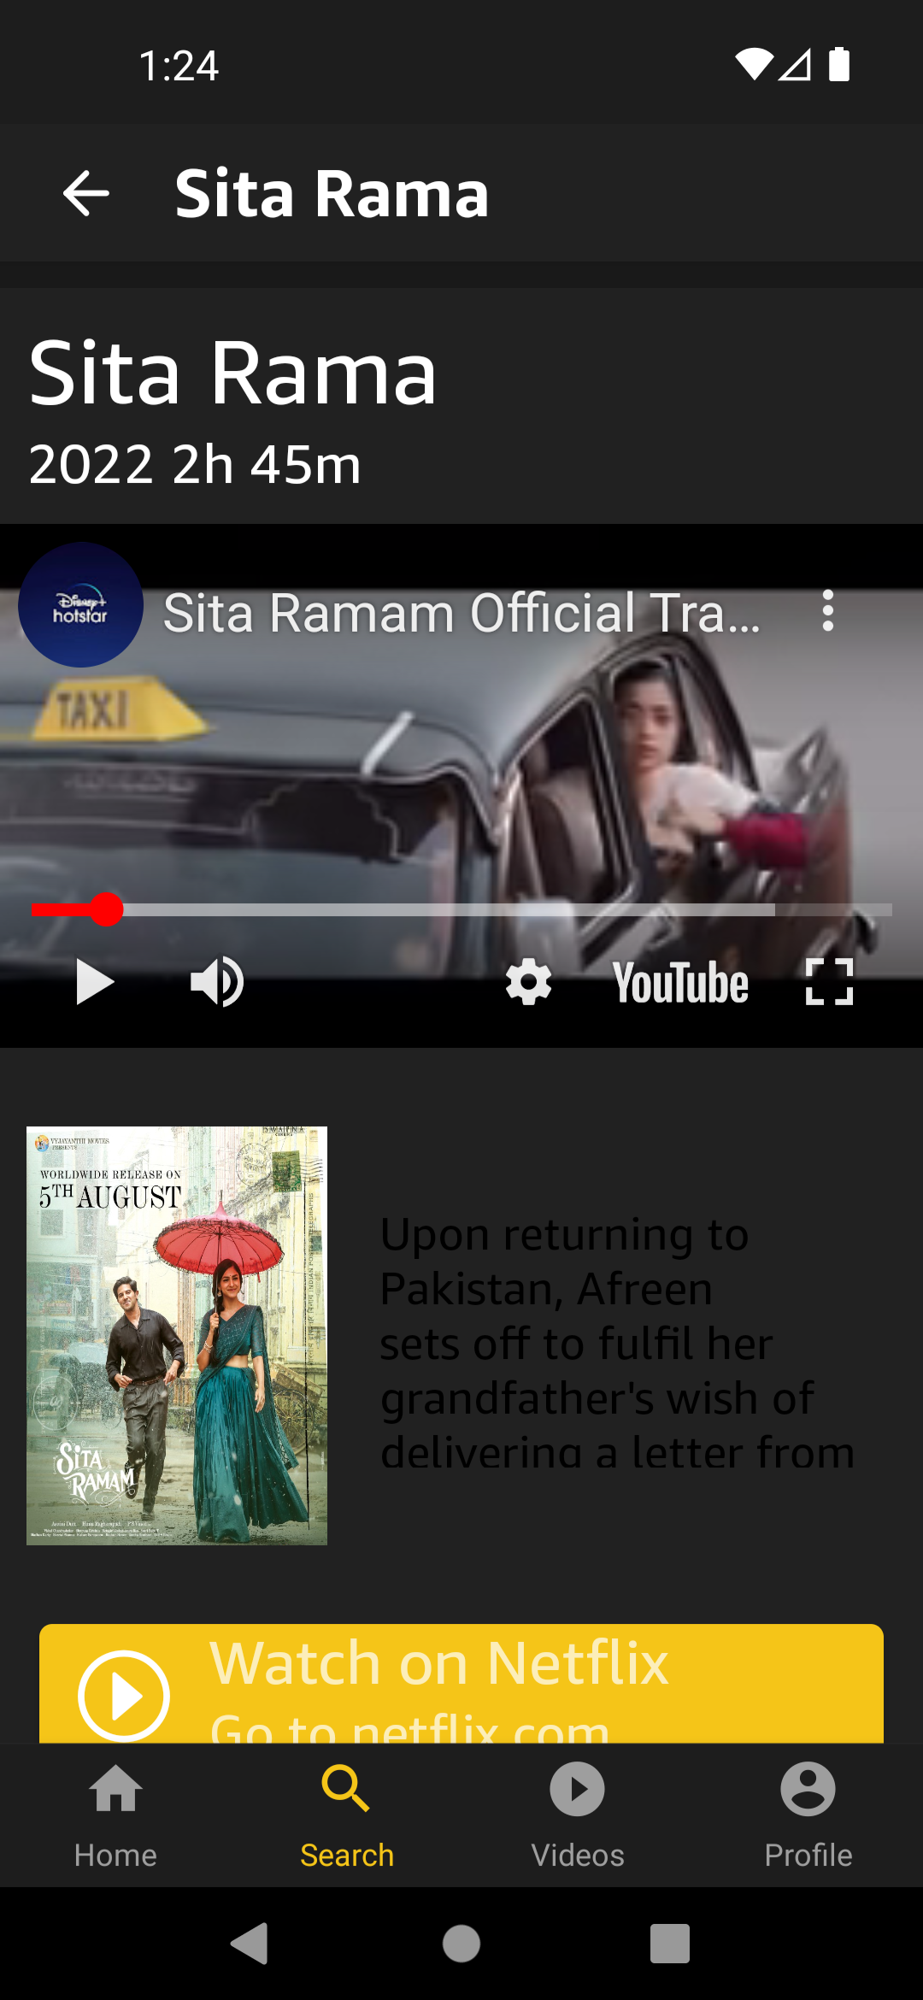

## SIGN IN PAGE MODULE:

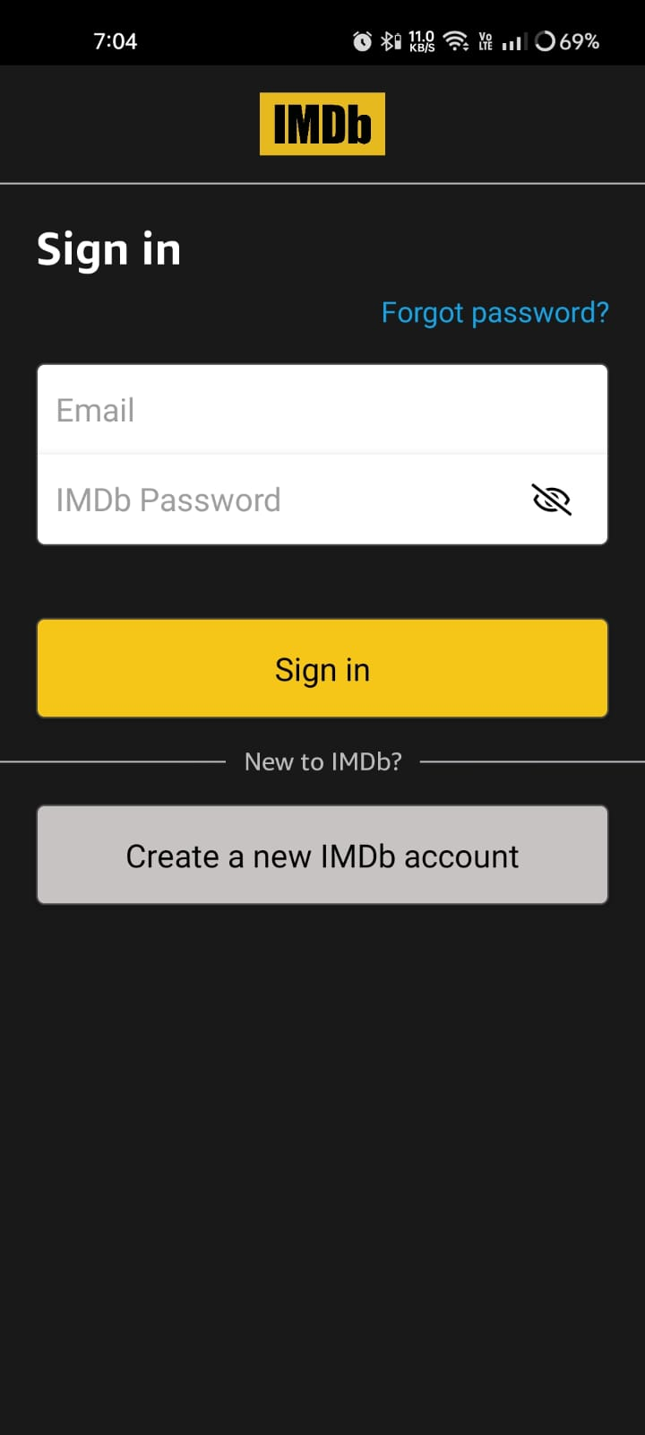If the user has an account, they can sign with their email and password.

## STATIC DATA ARRAY:

Data of all the movies.

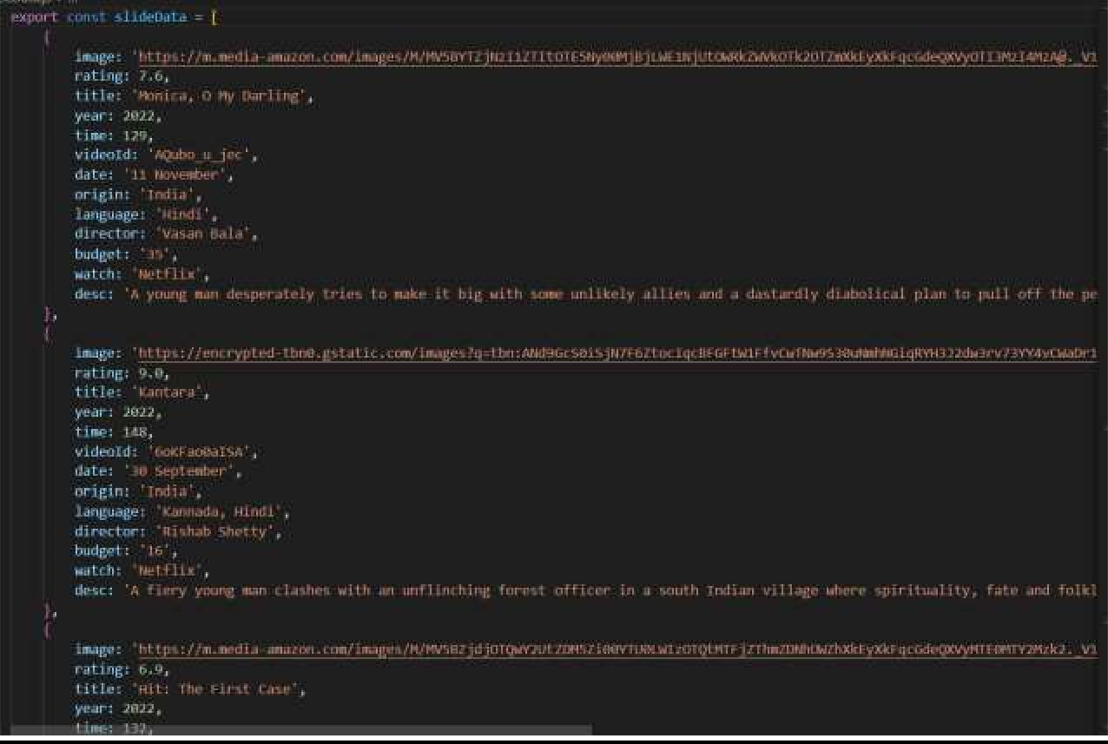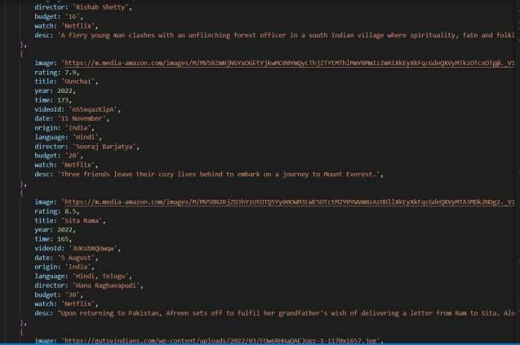

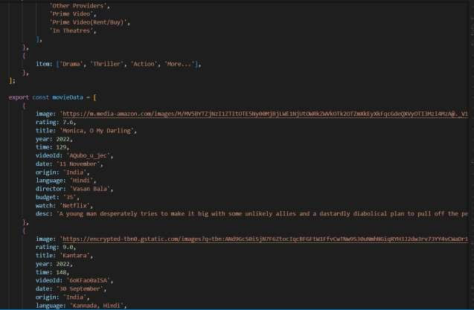

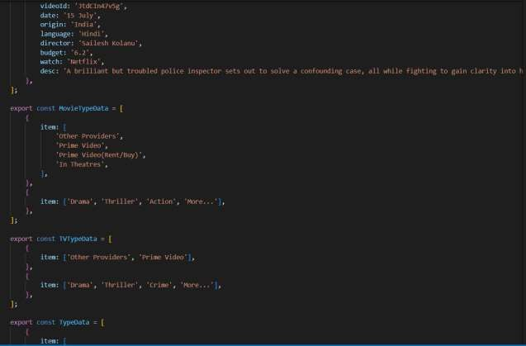

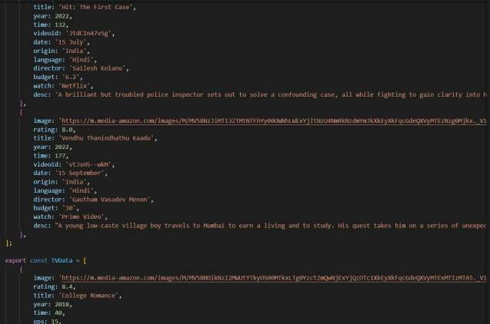

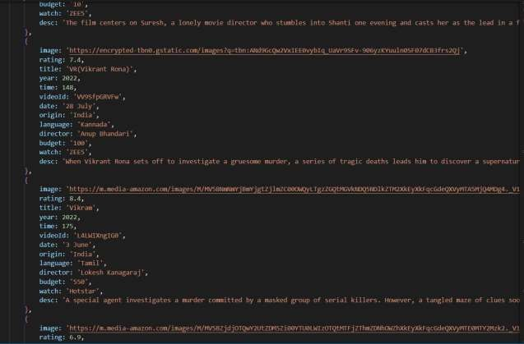

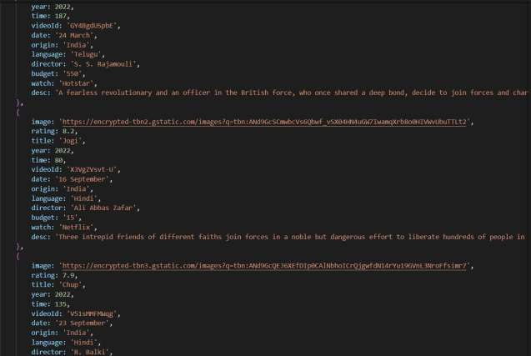

# FLOW CHARTS

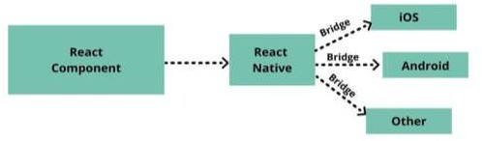

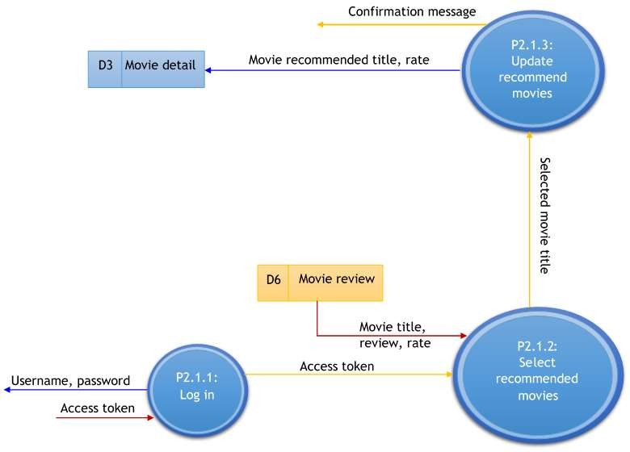

# TESTING

The testing phase is a part of system development lifecycle. Testing phase gives confidence to the developer in the system. During testing phase, different methodologies are considered like Unit testing, integration testing, and system testing. Testing phase determines whether application meets the requirements and serves the functionalities.

This system is developed in React Native for the web application. For large scale project these tests has to be successful. If each part of the system is working correctly and is behaving or providing the desired output for every kind of input then this system or project is successfully tested.

Here success means system has perfect data flow, scalability, availability for updates and reacts perfect on each input. Successful testing means the system ready to deploy. in the documentation language testing phase is important as It is the foundation of our whole project for the current and future.

Unit testing is the first phase of the testing. It provides the inner view of the project if there has any defect. Basically, in this phase, we are dividing the system into a very small working unit. We are testing that small unit of code. So, we can get to know if there was any error at the basic implementation level and can fix that. Majorly developer during development of that module has been tested. So, there has some time slice for testing during the development phase**.**

Various kinds of testing have been done while developing the website and

mobile application. Testing like checking the android version compatibility of

the application and trying to run the website on various devices and checking up their orientation that whether the website is compatible with the screen sizes or not. Other kinds of testing were done when I was trying to run the modules such as rating module that whether or not the rating is visible or not.

In the beginning the site was having some issues with the payment integration but then by running multiple test cases, at the end I got a solution to run it successfully and it came out perfect to be used by the staff of the company. The staff and the management of the company also tested the website and mobile application on their mobile phones, laptops, computers, tablets and in all of the cases it ran very well. Therefore, we can conclude that the testing phase took place greatly in the whole project phase

# CODING

## Sign in page

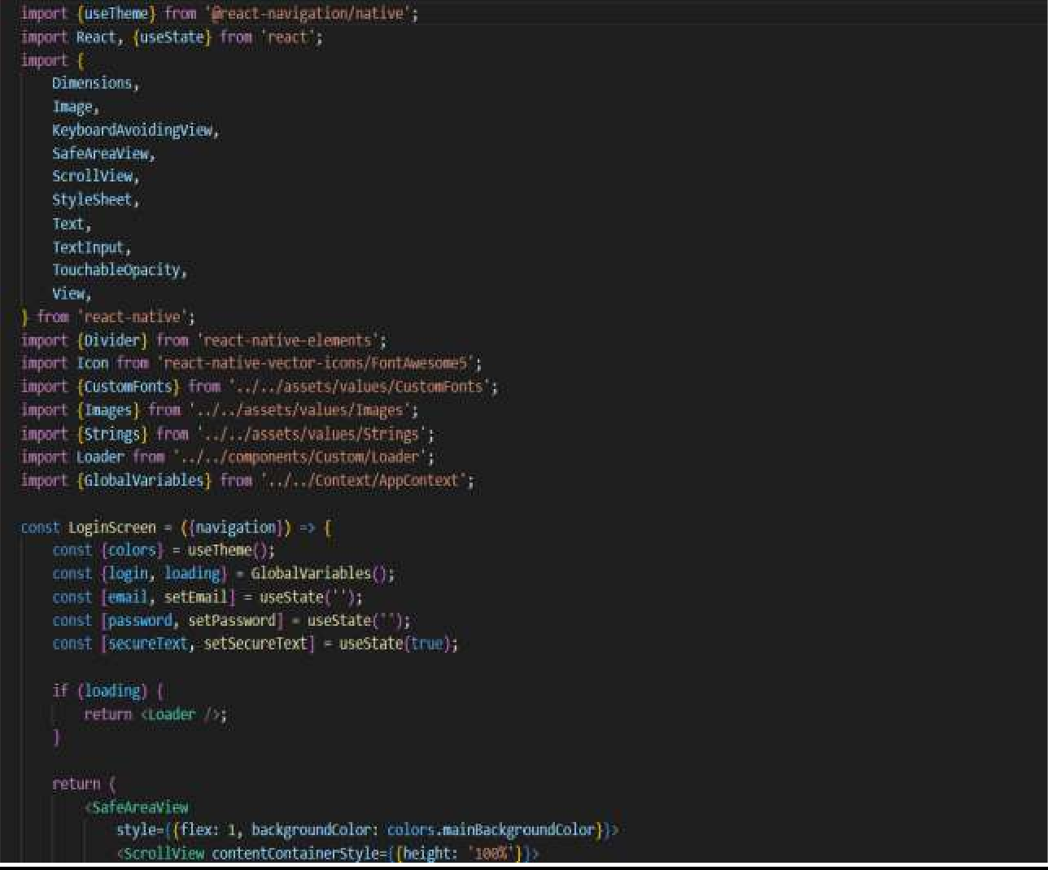

**Sign up page**

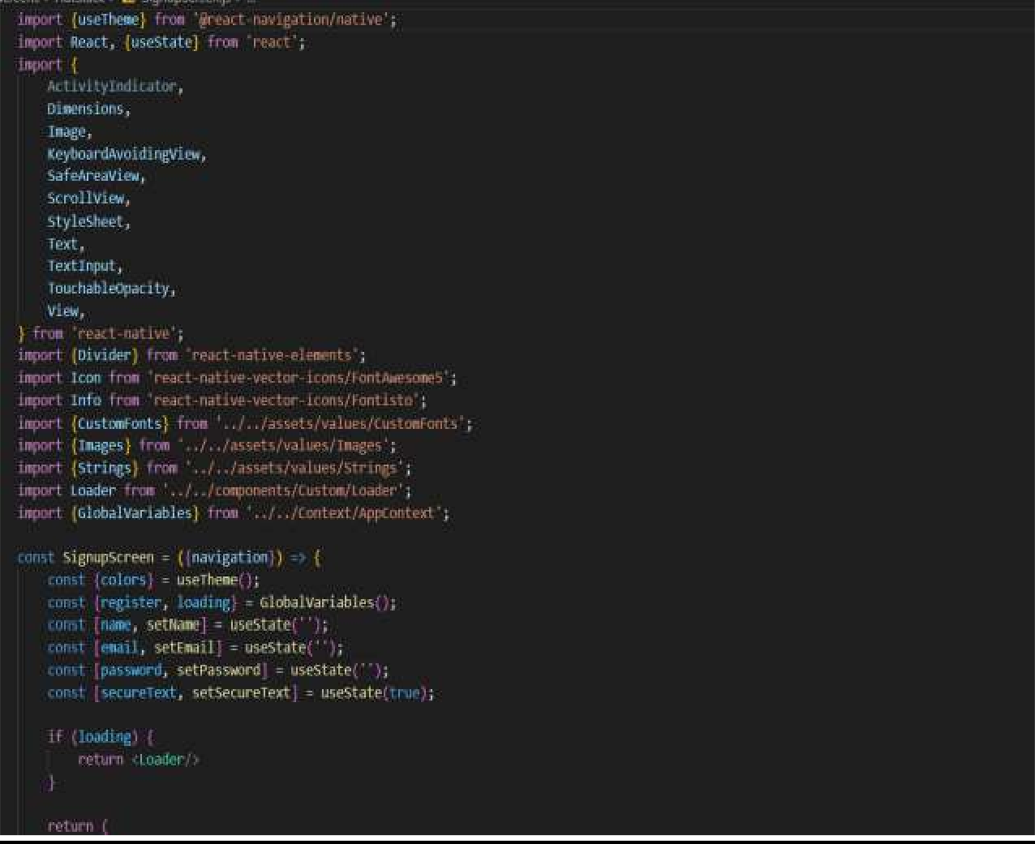

## Home page

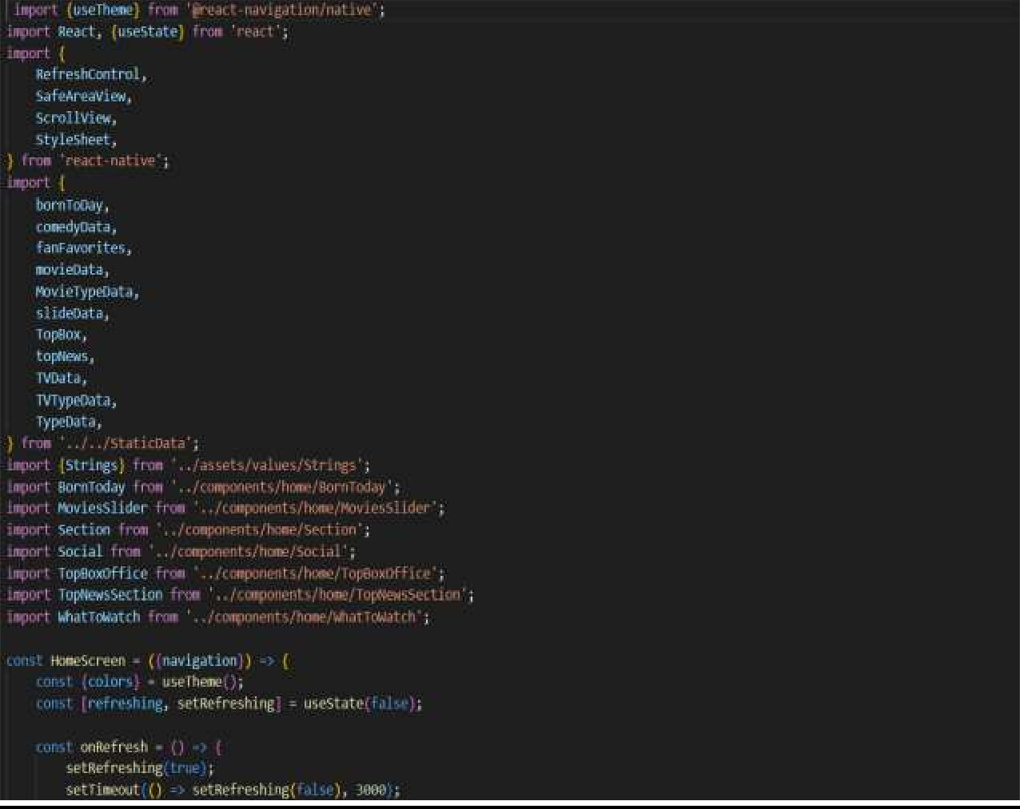

**Profie page**

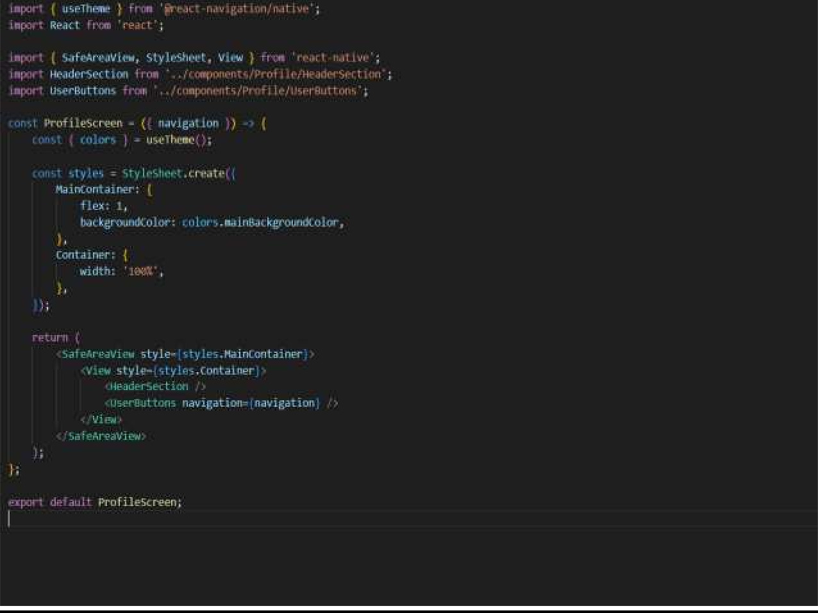

## Videos screen page

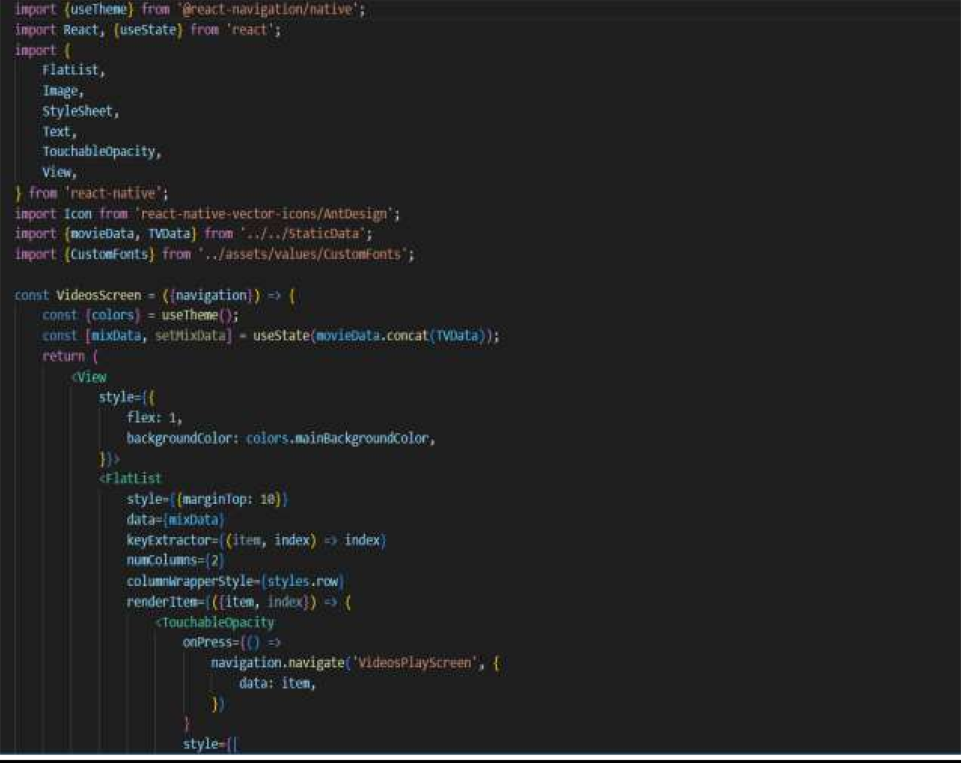

**Search Screen page**

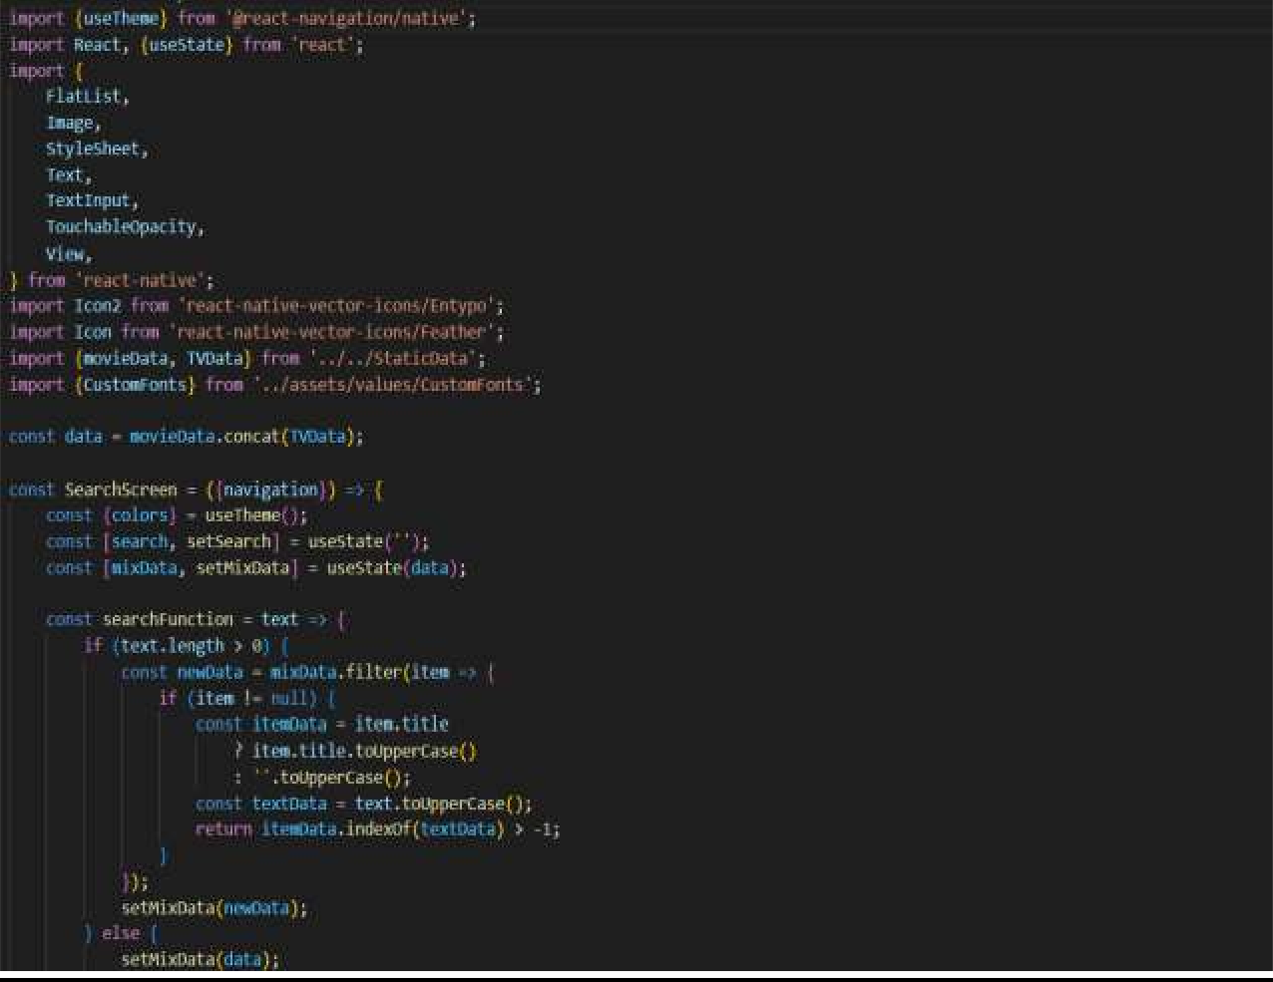

# FUTURE SCOPE

. The intent of this study of creating a way to predicting the success of movies using historical data was not a direct success, it shows that other features are necessary to accurately make a prediction. When trying to predict the rating of a movie a highest success rate of around 65% achieved when using 6 groups and 83% when using 4 groups. This could arguably be a good enough result and shows promise, but when it is compared to previous studies with similar methodologies the result equal in predictability.

When trying to predict the box office revenue of a movie a highest success rate of 15% was achieved, this result show that the method used in this study are difficult use for an accurate prediction, when compared to previous studies it shows that our method of preprocessing the data is not the best way to do it. When giving the model a binary decision of "will the revenue be greater than the budget" a success rate of around the high 60 percent was achieved.

Therefore, one can draw the following conclusion, using historical data to create a model to predict the rating of a movie shows promise and deserves to be properly evaluated. But then using the same historical data for trying to predict the box office revenue shows no promise using or method, previous studies have shown that it is possible to make accurate predictions, but the methods used in this study did not improve upon them. This project can be used in online platforms too. Additional features must also be considered to achieve this such as news analysis, movie story analysis and social network sentiment analysis and the information thus obtained could be added to the data set. We can also obtain input from the audience which can be added to the data set through Google forms to improve the result.

# CONCLUSION

This system has a very big scope to be useful in the real market and satisfy the requirement. As of now, this system has a 95% accuracy, using testing data set of 25 movies and using simple arithmetic calculation, which is amazing. There was a chance of may reduce the number when you include more data into the data set. In conclusion, we can say that this system is producing the result which is matching real-time results generated by other web sites.

So, this system can use as commercially and cater to the demand of users. This project gave me a lot of experience in the field of technology. I learnt how to build websites, mobile applications. I’ve become familiar with other technologies too. I learnt how to use APIs, I learnt how to use Android Studio, I learnt to create websites on Localhost and much more.

Apart from the technology part, I also learnt communication skills in a working environment, I learnt how to deal with clients and their requirements and always overdeliver to what they ask. I feel lucky to be a part of this organization and I am really thankful to the company for providing me this opportunity. I am confident that I can use these skills which I learnt in my industrial training for the good self of a company and I can definitely contribute to the growth of a company as well for sure

REFERENCES

1. [https://developer.android.com/studio?gclid=Cj0KCQiAtICdBhCLARIsALUB](https://developer.android.com/studio?gclid=Cj0KCQiAtICdBhCLARIsALUBFcFymsERcKMXpMAI1_wZnzwQFZEJdoea6NhNvSs3qaHbT2i-oFGrFpgaAl28EALw_wcB&gclsrc=aw.ds) [FcFymsERcKMXpMAI1_wZnzwQFZEJdoea6NhNvSs3qaHbT2i-](https://developer.android.com/studio?gclid=Cj0KCQiAtICdBhCLARIsALUBFcFymsERcKMXpMAI1_wZnzwQFZEJdoea6NhNvSs3qaHbT2i-oFGrFpgaAl28EALw_wcB&gclsrc=aw.ds) [oFGrFpgaAl28EALw_wcB&gclsrc=aw.ds](https://developer.android.com/studio?gclid=Cj0KCQiAtICdBhCLARIsALUBFcFymsERcKMXpMAI1_wZnzwQFZEJdoea6NhNvSs3qaHbT2i-oFGrFpgaAl28EALw_wcB&gclsrc=aw.ds)
2. [https://www.npmjs.com](https://www.npmjs.com/)
3. <https://reactnative.dev/>
4. <https://www.imdb.com/>
5. <https://youtu.be/bES5bMSL54M>